**ML Assignment Report**

**Task 1: Linear Regression**

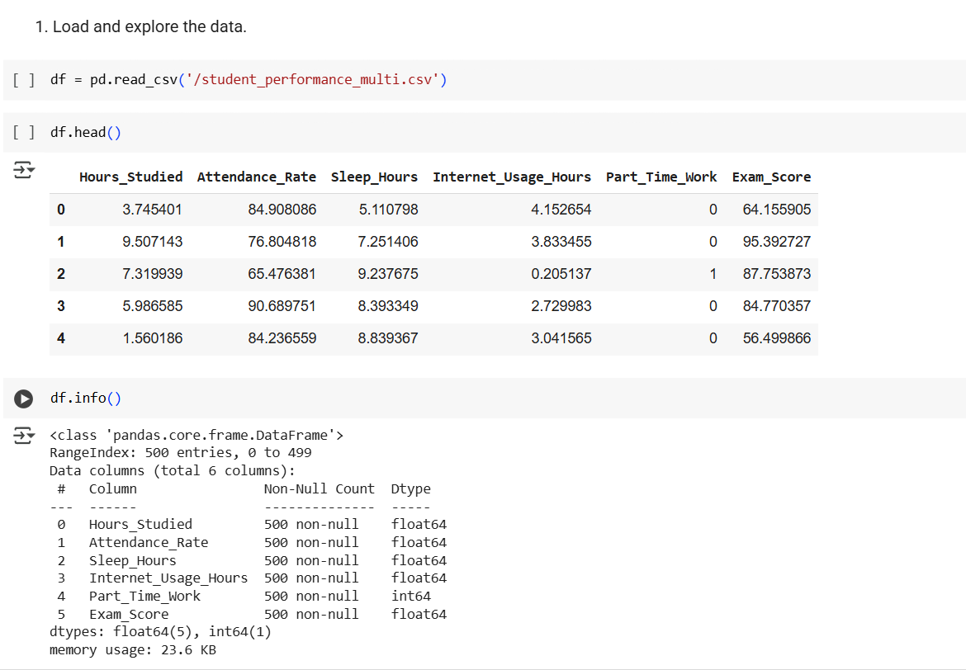

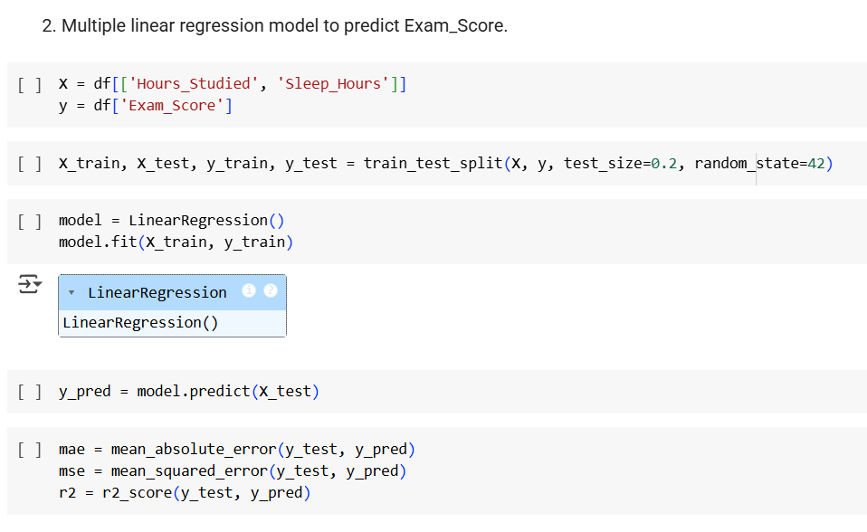

**Task 2: Classification Model**

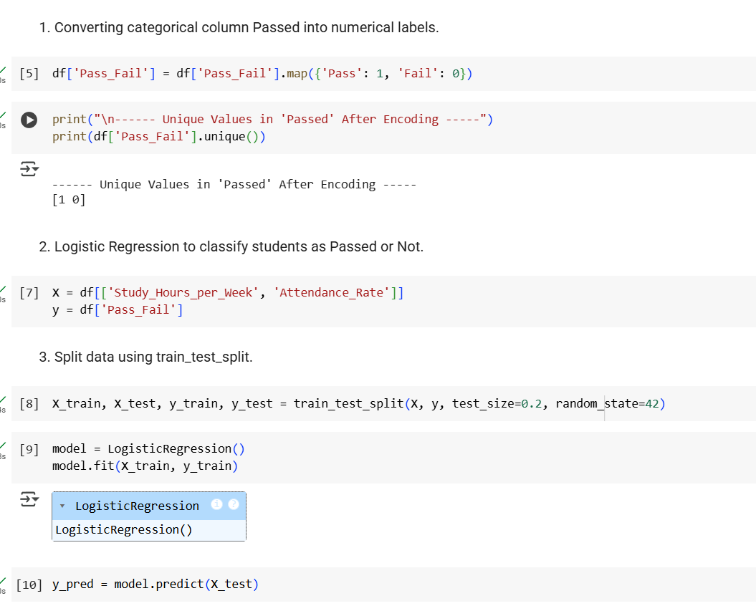

**Task 3: Model Comparison**



